Design of masonry according to EC6
www.ec6design.com

Unique tool for engineers arises international attention. The Danish Technological Institute is offering, as the only Institute in Europe, an on-line calculation and design program consistent with EC6.

EN 1996-1-1 (EC6) will be compulsory in Europe from 2010. In Denmark the code has been compulsory since 2008 and the complicated rules and models in the code have increased the demand for an advanced tool to ease the static analyses. Consequently this program “Design of Masonry” was developed in 2006 for the benefit of Danish Consulting Engineers.

The program was created on top of a former program initiated in 1993 referring to the Danish code of rules. Since the difference between the Danish code of practise and EC6 eventually was minor, the adjustment of the program consequently was minor.

The Danish Technological Institute has experienced a major interest for this program from European engineers, institutes and authorities. An English version has thus been developed in 2008 and placed on the domain www.EC6design.com.

During development of the English version improvement of user friendliness compared to earlier versions has been in focus. The program is furthermore prepared for other languages in case these facilities should be demanded. (E.g. a German and French version would be an obvious step).

Parameters from National Annexes (I.e. safety factors and parameters of strength are part of the input facilities and thus easily implemented in the calculations)

Approximately 200 (or 90 % of the) Danish consulting engineers, universities and institutions are using the program giving a good feed-back for necessary improvements.

The subscription fee is 255 Euro per year and includes free support via e-mail or telephone. The program can be used without charge for 3 weeks. Just send an e-mail to (poul.christiansen@teknologisk.dk) before the period has passed and the invoice will be cancelled.

The program consists of different modules:
- Calculation of loads
- Combined walls
- Horizontal loaded rectangular walls
- Horizontal loaded polygonal walls
- Vertical loaded wall (according to Ritter Method)
- Vertical loaded wall (according to EC6)
- Vertical loaded walls (storey high walls of AAC)
- Veneer walls
- Tie wires
- Stabilizing wall (in-plane loaded)
- Arches
- Masonry beams

Furthermore a module to determine the parameters of strength for different combinations of units and mortar is developed.
Password and username is determined of the user during the first log-on. I.e. if you wish to use or just try the program type: www.EC6design.com in the browser and follow the explanations.

Figure 1. Input is easily given through input fields
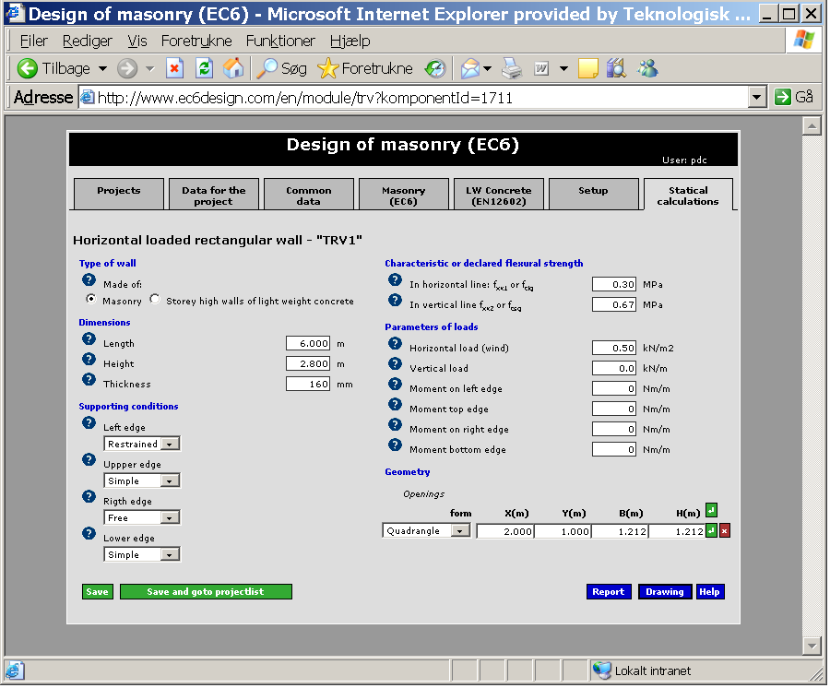

Figure 2. A context sensitive help text is always available
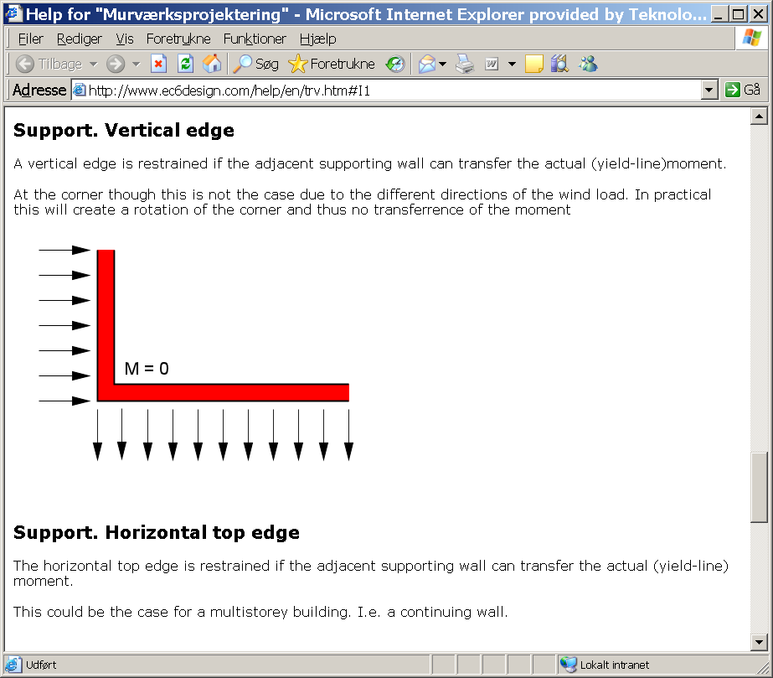

Figure 3. Drawing of input gives an overview and excludes grave errors
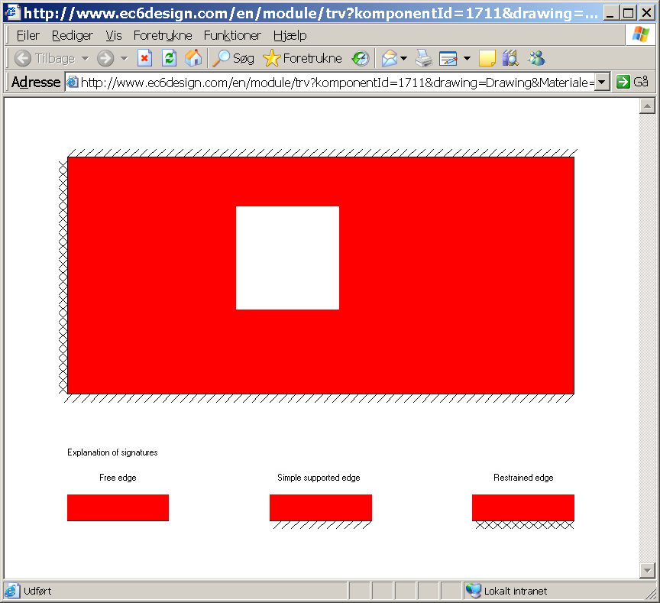

Figure 4. The result comprises the load capacity, utilization degree and the graphic result from the yield line iteration
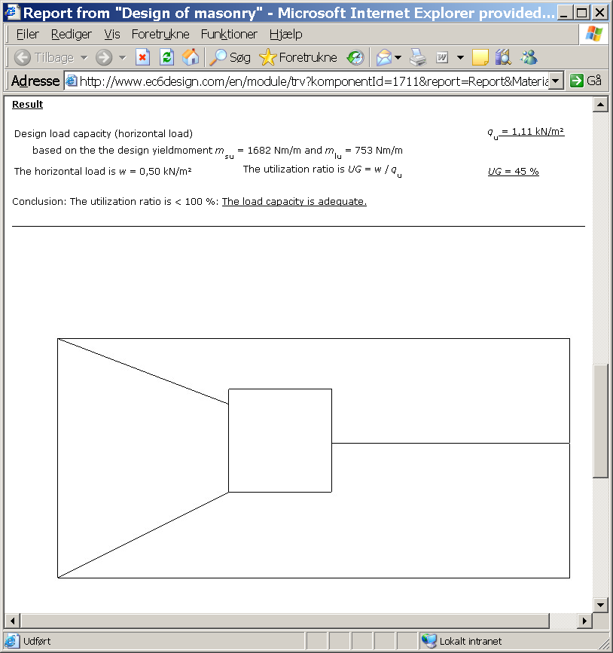

If you have any questions do not hesitate to send an e-mail to poul.christiansen@teknologisk.dk

